Web server & Application server
- Install nginx and run nginx on port number 81.
- Install nginx first using command sudo yum install nginx
- systemctl start nginx
- Systemctl status nginx

- To change the port number from 80 – 81, we to use command : cat /etc/nginx/nginx.conf
- sudo vi nignix.conf ( change number from 80 to 81) save esc+shift+;+wq
- now check 81 is updated or not to test use command: sudo nignx -t (successful)
- now restart nginx use command: systemctl restart nginx
- now go to browser paste the ip address +:81 +enter
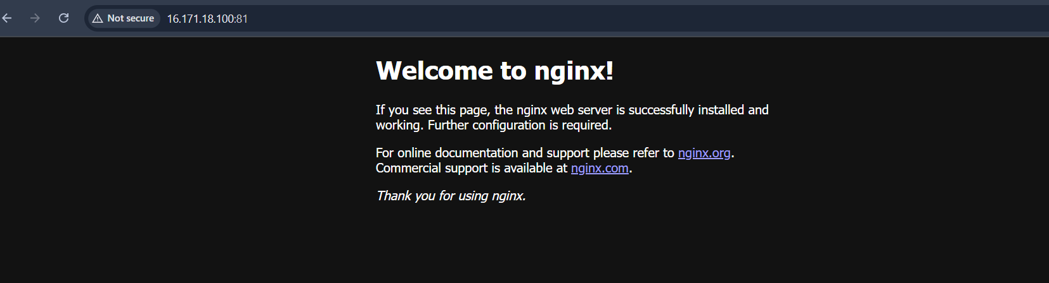

- Deploy a sample index.html file on nginx.
- 1.Command: cd /usr/share/nginx/html
- 2. Command: vi index.html ( once vi editor opens with script. So change title near title space (welcome to india)+ enter
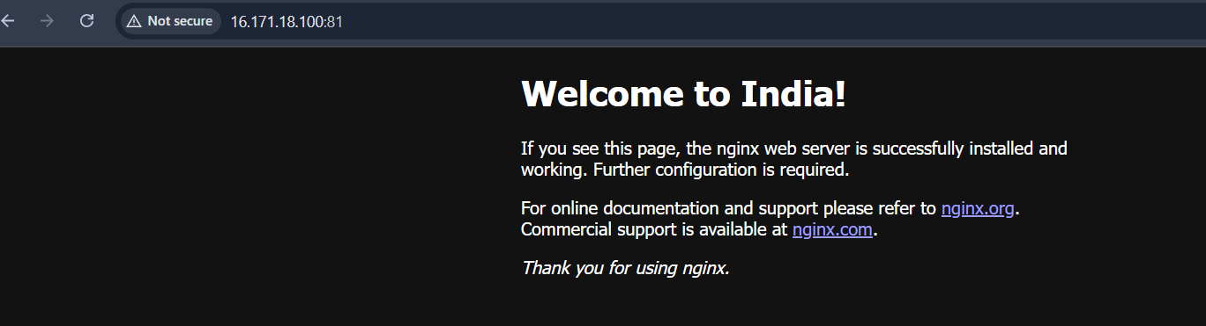
- Install Apache and run Apache on port number 82
- Install Apache Command: yum install httpd
- 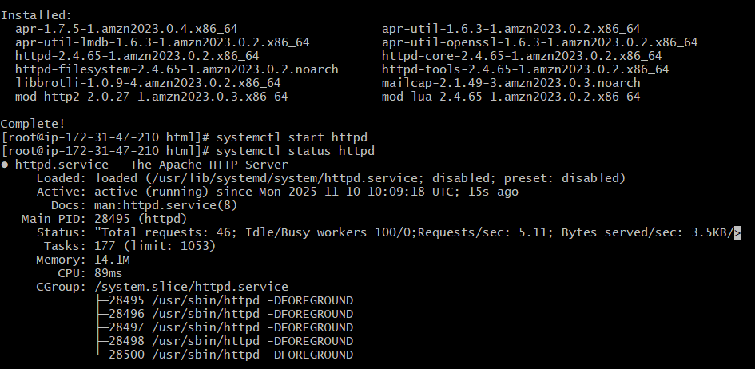
- 1. To find file. Command : find -name httpd.conf
- 2. To see config. Command: sudo vi /etc/httpd/conf/httpd.conf
- 3. Find listen 80 and replace it with 82 and save and exit.
- 4. To test use command: sudo httpd -t
- 5. Systemctl restart httpd to restart and systemctl status httpd to check the status.
- 6. Copy the ip address from aws and paste in browser and :82 at last+ enter output should be “ It works”.

- Deploy a sample index.html file on Apache.
- 1. To change cd use command: cd /var/www/html
- 2.Command: ls, I don’t have any files. So, created a file index.html use command : touch index.html
- 3.Copyed an sample html code from browser and pasted it in file using command: vi index.html
- 4. To restart use command: sudo systemctl restart httpd
- 5. To test whether its working or not use command: sudo httpd -t
- 6. Now go to browser and releod it. Output: welcome to my page.
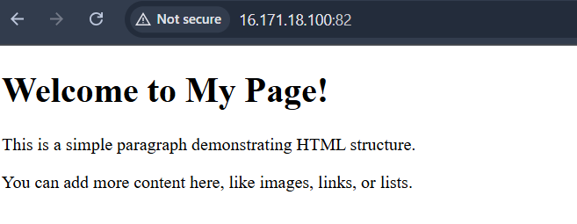

- Install Apache tomcat on port number 8082
- 1.Update or install java script use command: yum install java
- 2. Cd to opt use command: cd /opt/
- 3. Go to browser search for apache tomcat > downloads > tomcat 9 version > tar.gzip file copy link and open gitbash use command: wget paste the link+enter
- Ls once we see file named apache-tomcat-9.0.111.tar.gz
- Now unzip the using command: sudo tar -xvf file name( output: apache-tomcat-9.0.111. using command: mv rename the file.
- Cd tomcat > cd bin/ > ls now we can ./startup.sh and ./shutdown.sh
- Use command: ./startup.sh , start the tomcat.
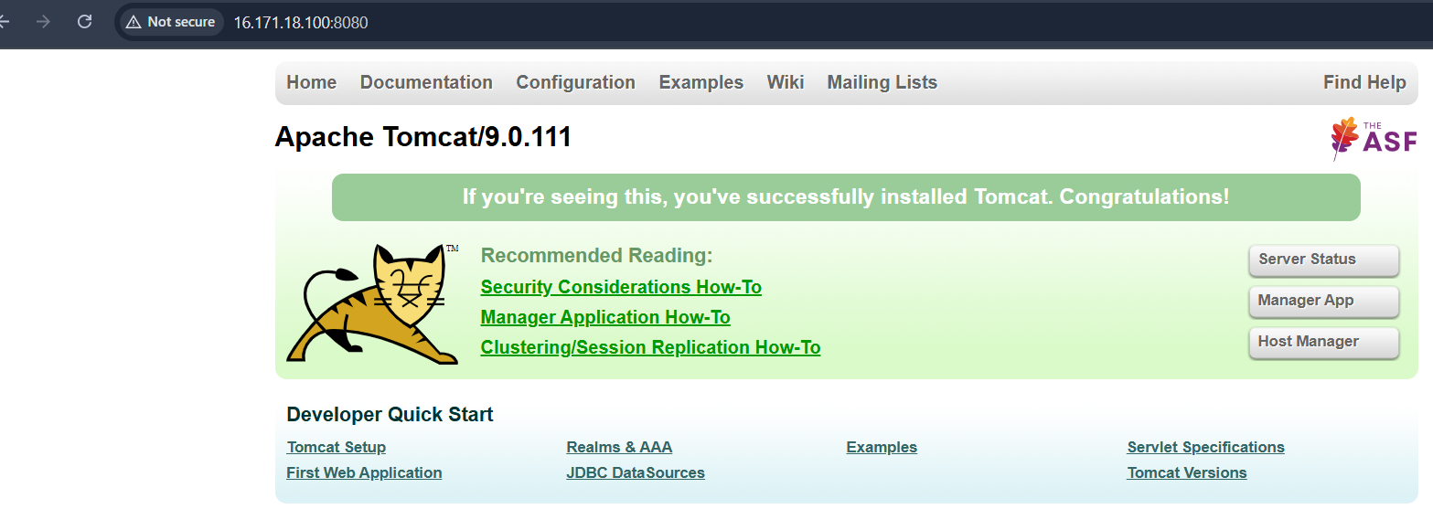
- Change port number from 8080 to 8082
- 1. To change port number, we need to go into config file. Use command: cd /opt/tomcat/conf > ls > you see file named server.xml > sudo vi server.xml and once it opened change port number from 8080 to 8082 and save and exit vi
- Now we need to go back from conf to bin. Use path cd /opt/tomcat/bin/ > ls and use command: ./shutdown.sh and ./startup.sh
- Now go to aws copy ip address > browser paste ip address and add :8082 +enter. Now we can see the output below (screenshot).
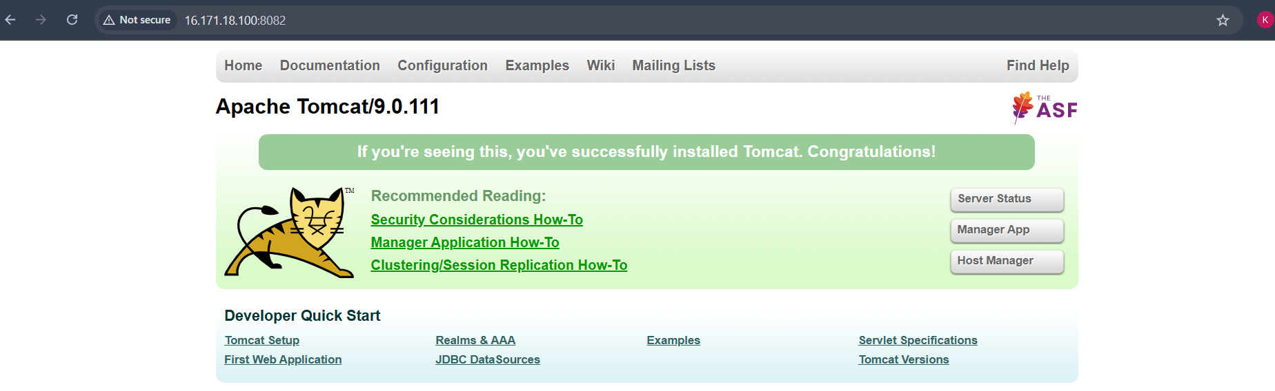
- Deploy a sample app on webapps
- 1. Command: cd tomcat > ls we can see webapps their.
- Command: cd webapps > wget paste sample.war link from browser > ls we can see sample.war file here. > vi sample.war and exit.
- Go to browser paste ip and add +8082/sample/ > output: hello world.
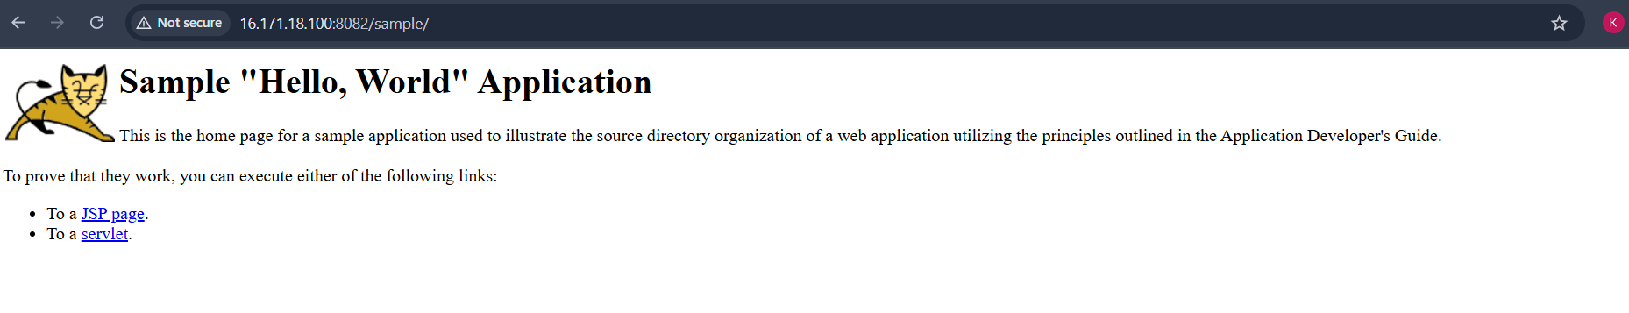
- To create our own application use command: cd sample > ls > vi index.html > edit the name of application and save & exit
- Go to browser paste id and add+8082/sample+enter ( output added below)
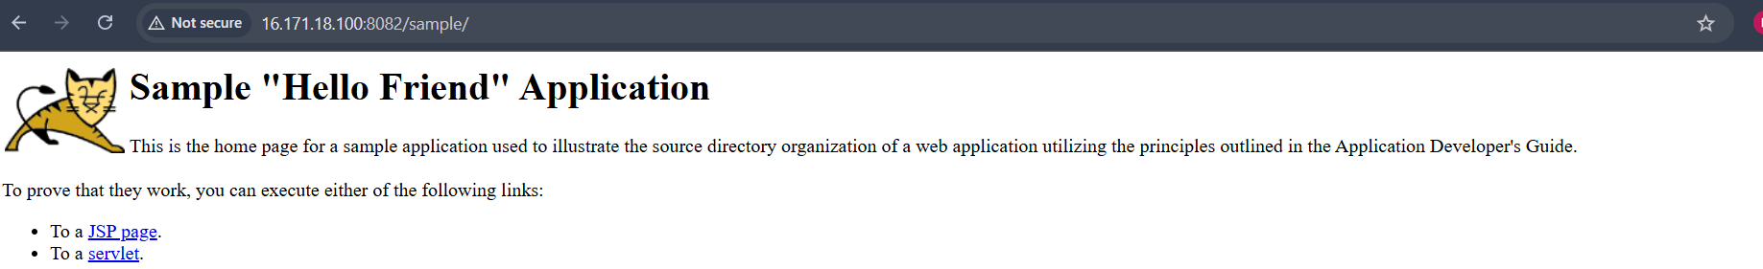
- Create a tomcat.service file for tomcat
- 1. Use command: cd/etc/system/system and create file using command: touch tomcat.service
- 2. Use command: sudo vi /etc/systemd/system/tomcat.service
[Unit]
Description=Apache Tomcat Server
After=network.target

[Service]
Type=forking

Environment=JAVA_HOME=/usr/lib/jvm/java-25-amazon-corretto
Environment=CATALINA_HOME=/opt/tomcat
Environment=CATALINA_BASE=/opt/tomcat

ExecStart=/opt/tomcat/bin/startup.sh
ExecStop=/opt/tomcat/bin/shutdown.sh

User=root
Group=root
Restart=always

[Install]
WantedBy=multi-user.target
Save & exit. Now use command: sudo systemctl daemon-reload, sudo systemctl start tomcat, sudo systemctl status tomcat
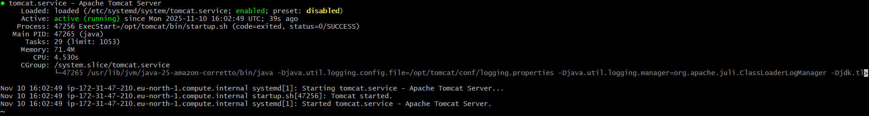

- Configure HA Proxy server
- Launch 3 servers in ec2 : server 1, sever 2, haproxyserver
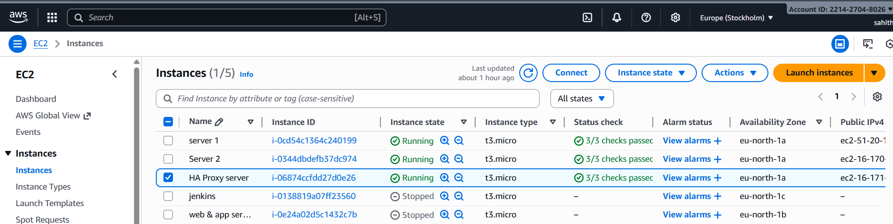

- Run following command to Access the Server-1
1.ssh -i your-key.pem ec2-user@Pubipaddress of Server-1 instance
- 2. Sudo -i
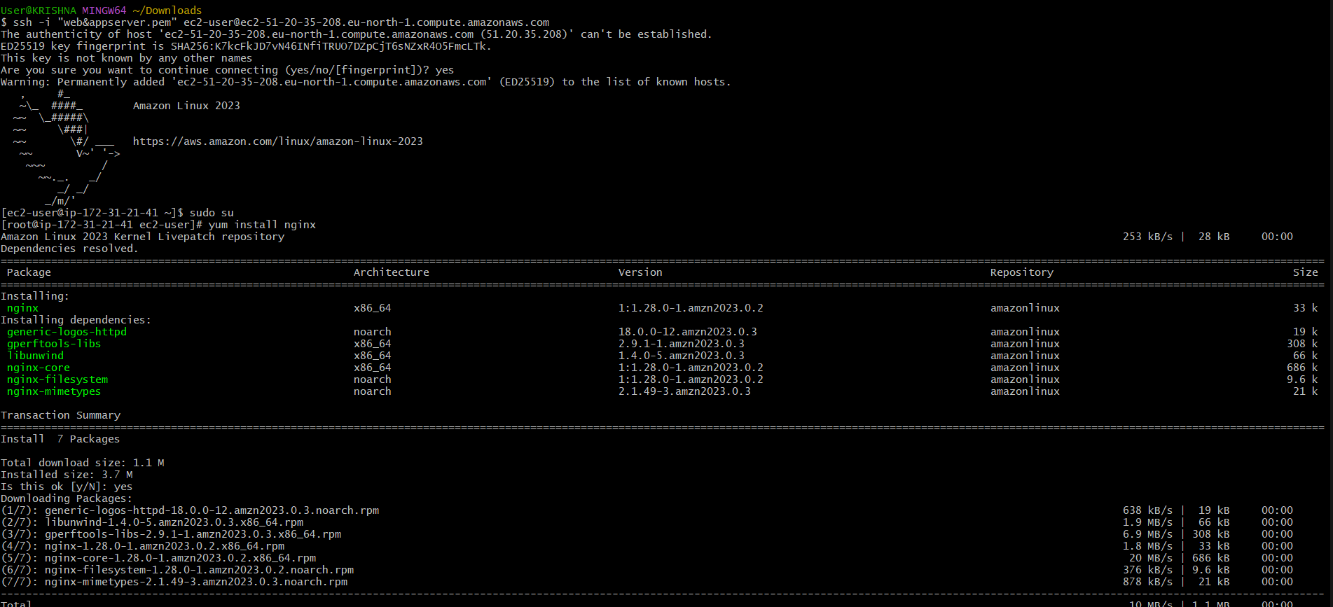
- yum update -y
- Yum install httpd -y
- Vi /etc/hosts
- Add HA-Proxy-Server Pubic IP Address
- Run below command on Server-1
- ping load_balancer -c 4
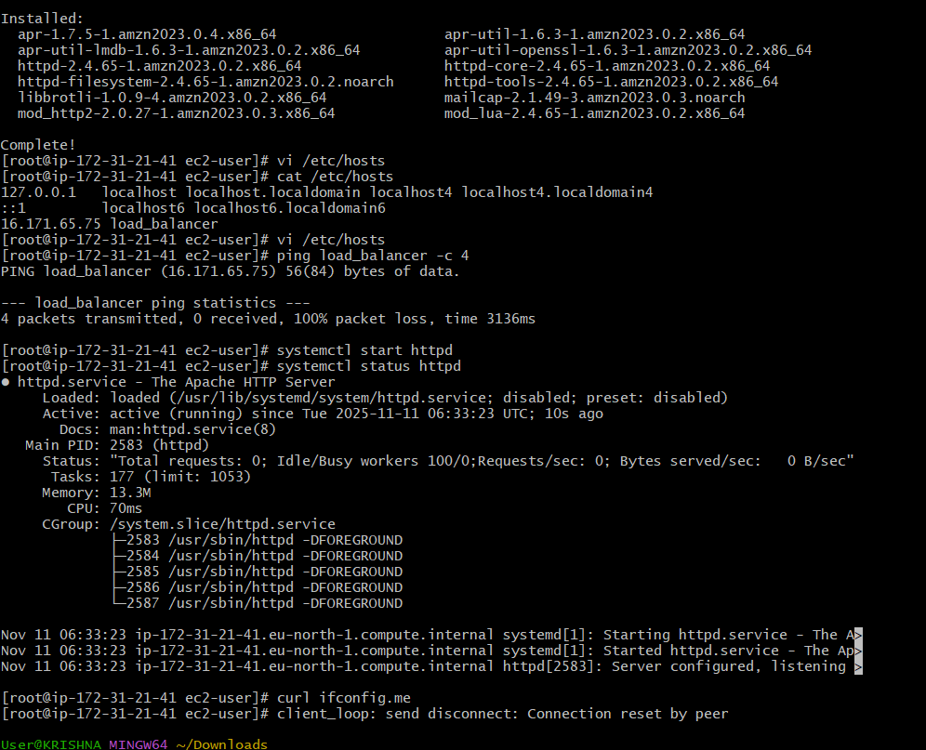
- systemctl start httpd
- systemctl status httpd
- Browse with Server-1 Public IP address:80 it will work Server 2

Run following command to Access Server-2
- ssh -i your-key.pem ec2-user@Pubipaddress of Server-2 instance
- sudo -i
- yum update -y
- yum install nginx -y
- sudo dnf install nginx -y

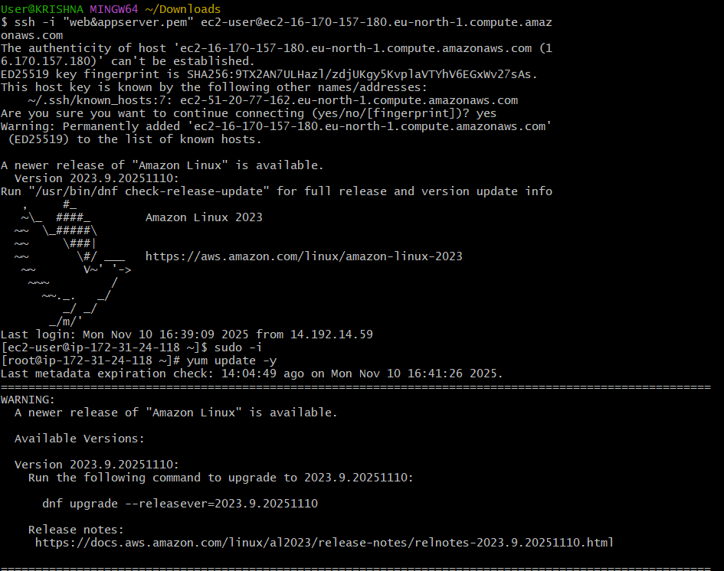
- vi /etc/hosts
- cat /etc/hosts
- Add HA-Proxy-Server Pubic IP Address

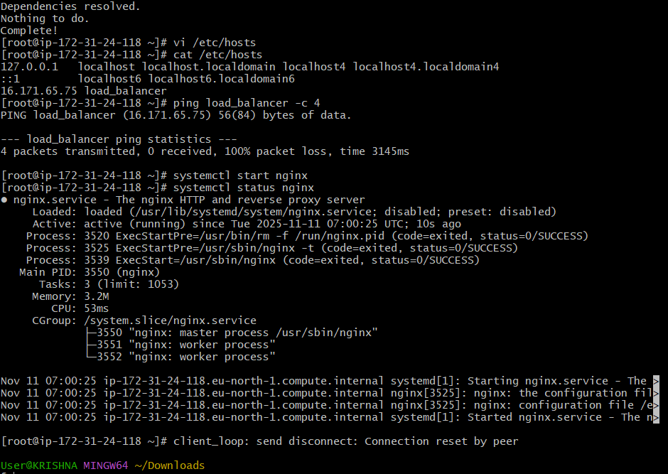
- Run below command on Server-2
- ping load_balancer -c 4
- systemctl start nginx
- systemctl status nginx
- Browse with Server-2 Public IP address:80 it will work

HA-Proxy-Server Steps:
- Run following command to Access HA-Proy-Server
- ssh -i your-key.pem ec2-user@Pubipaddress of HA-Proxy-Server instance
- sudo -i
- yum update -y
- yum install haproxy -y
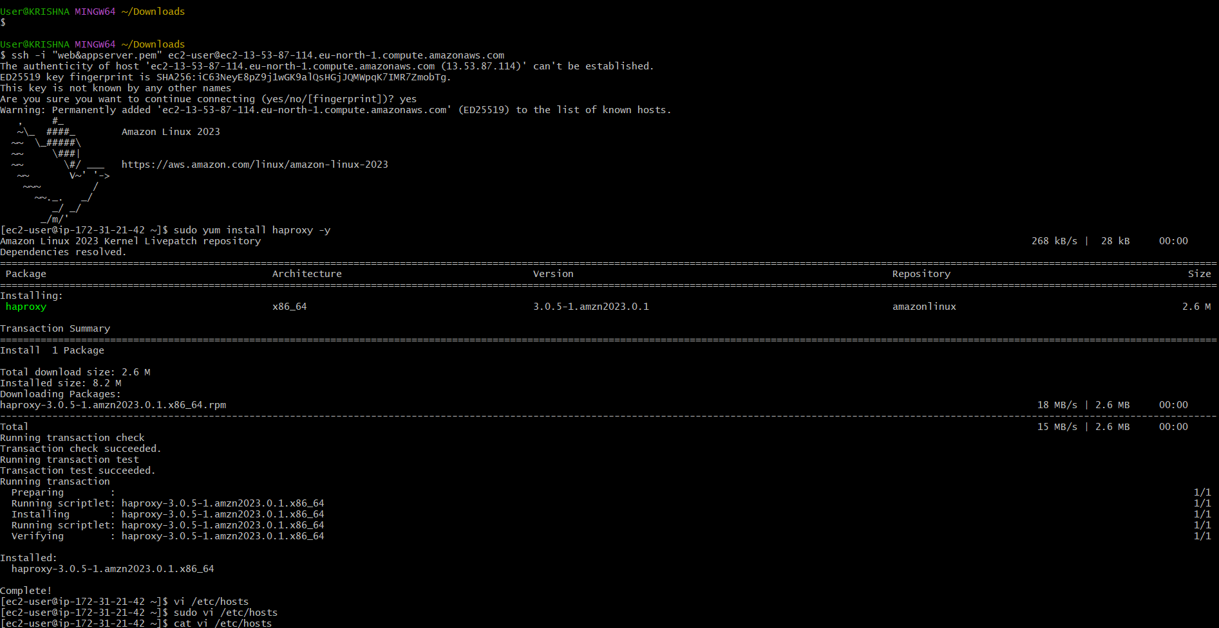
- vi /etc/hosts
- Add Server-1, Server-2 Public IP’s
- vi /etc/haproxy/haproxy.cfg
- Add Server-1, Server-2 public IP’s
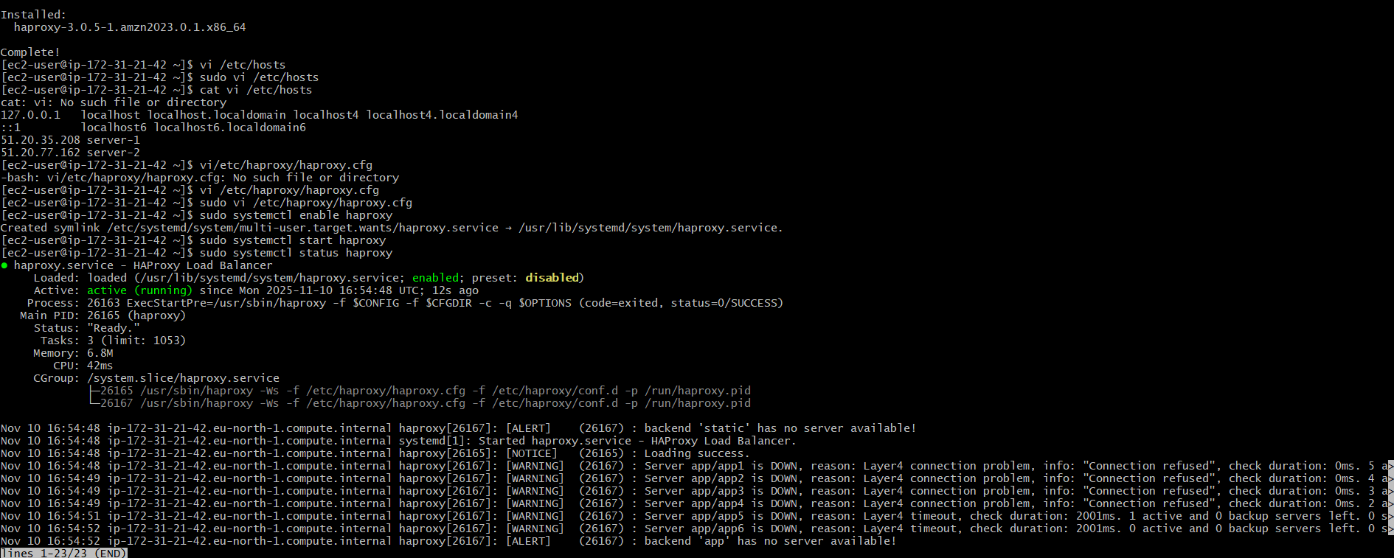
- systemctl enable haproxy
- systemctl start haproxy
- systemctl status haproxy
- now browse with HA-Proxy-Server PublicIP:80 it will distribute load to server-1, server-2


